**DevOps Advance - EC2 instance**

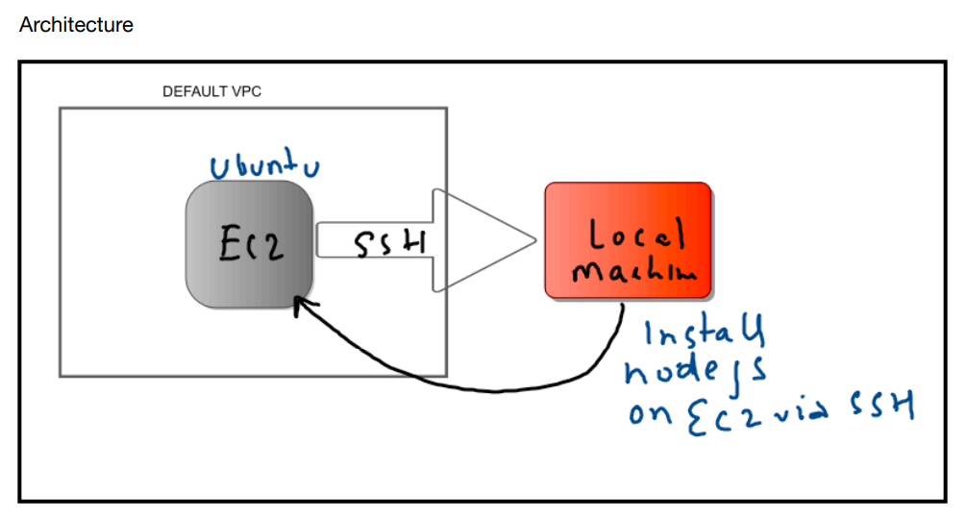

**Login to the AWS management console

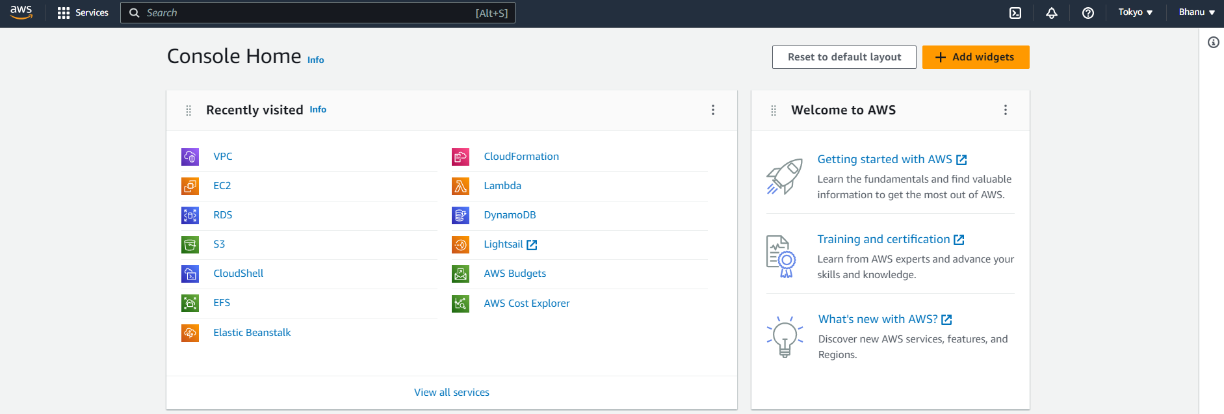

**Step1:**

Choose EC2 and click on launch instance.

Create EC2 Instance with Ubuntu AMI.

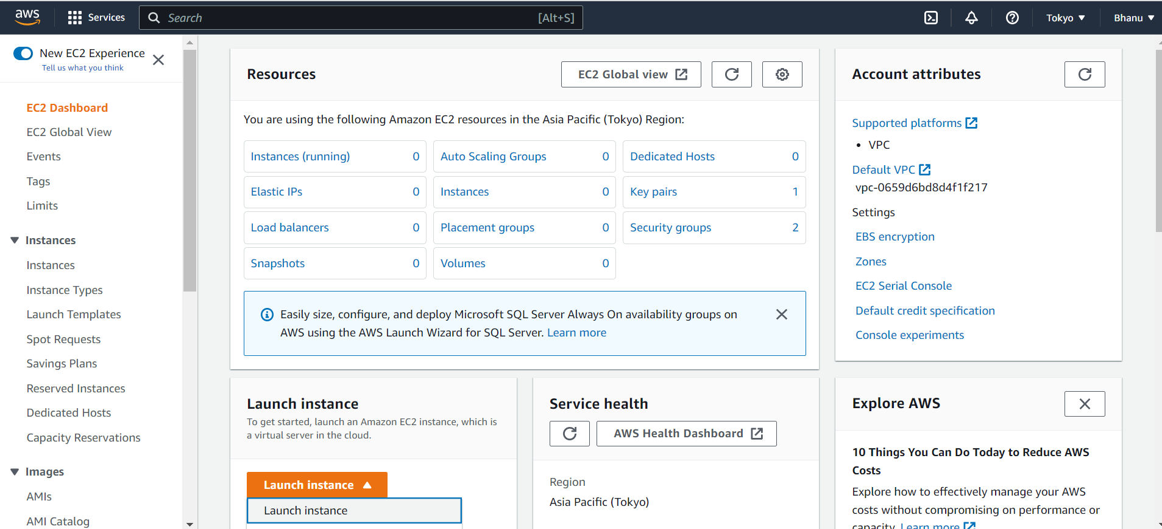

**Give name for the instance as “mywebserver”.

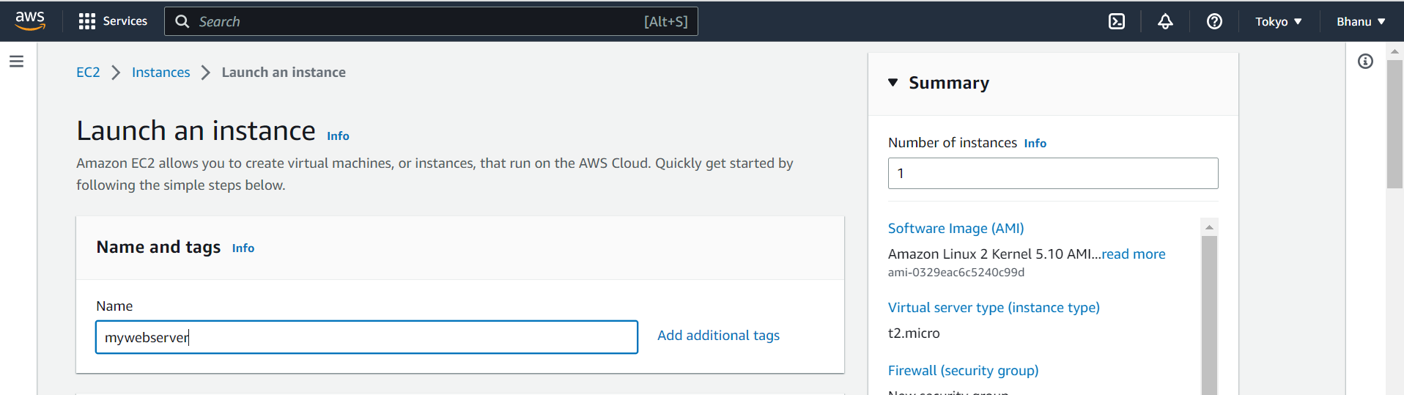

**Select the Ubuntu AMI. And the type of instance is t2.micro.

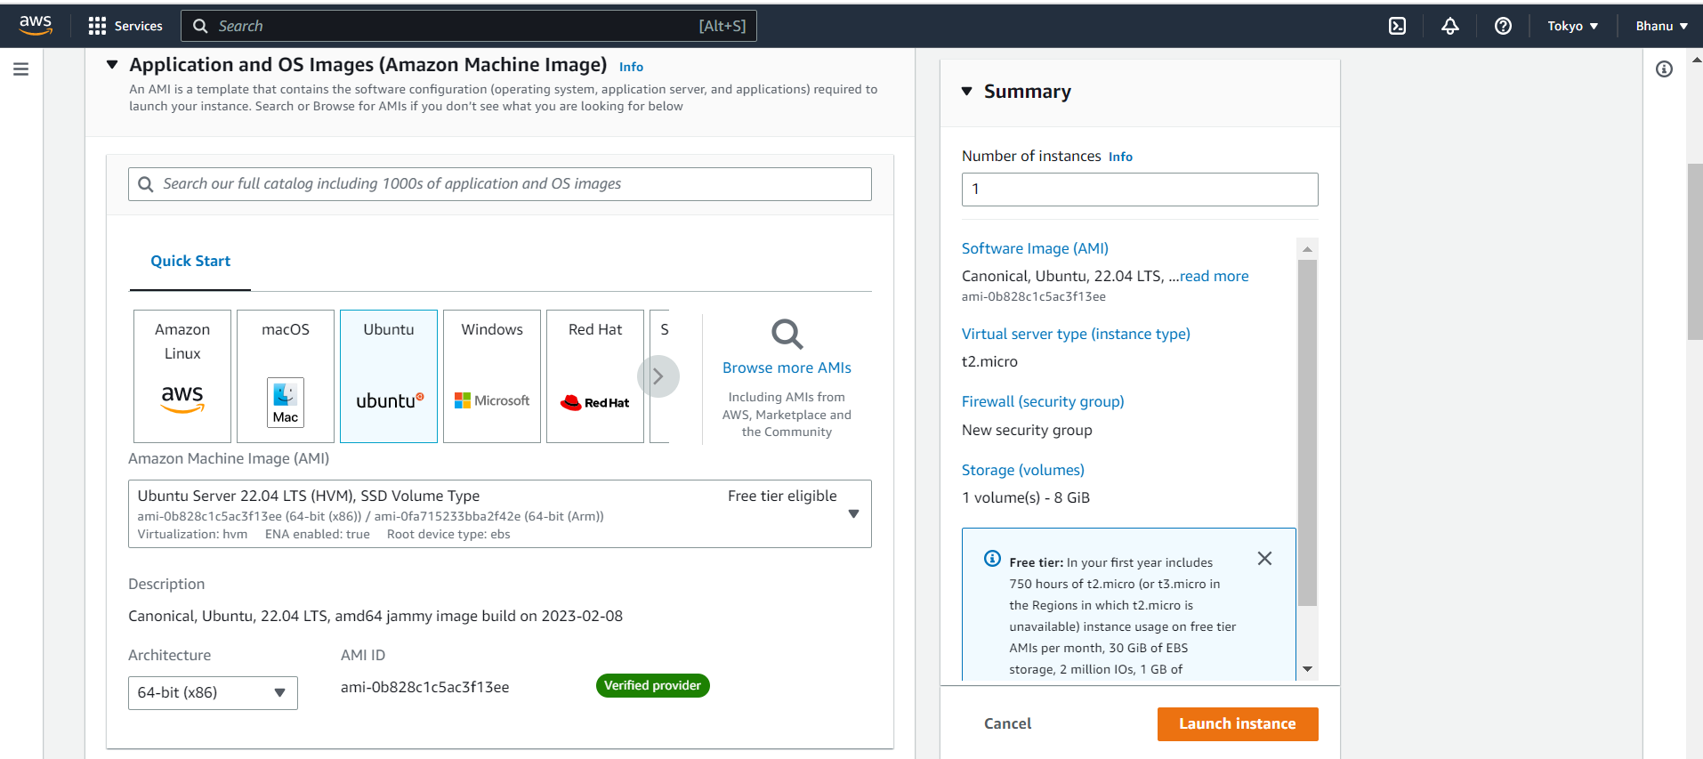

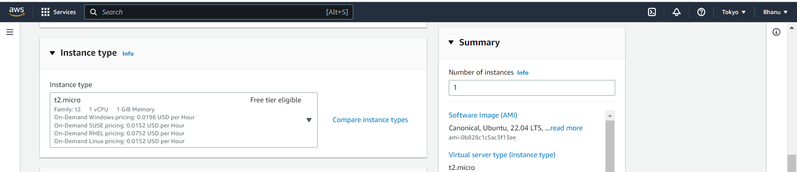

**Step2**:

Create key pair for SSH access.

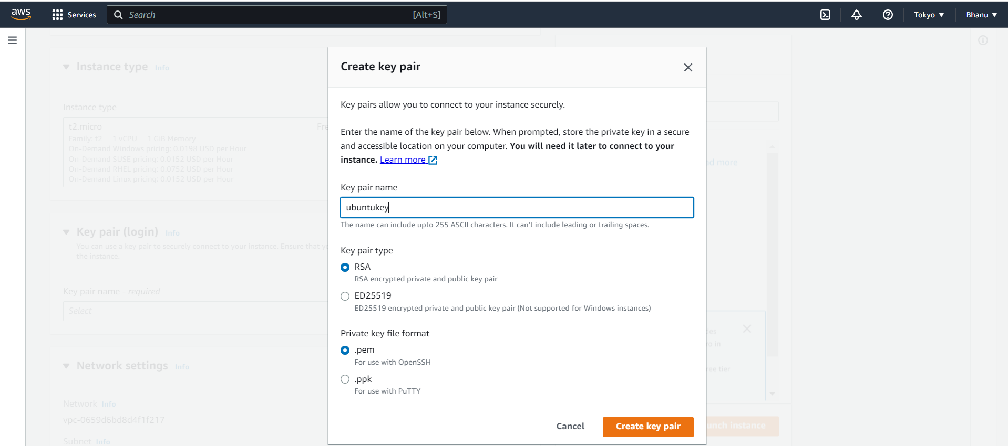

**Keypair is downloaded to the local machine.

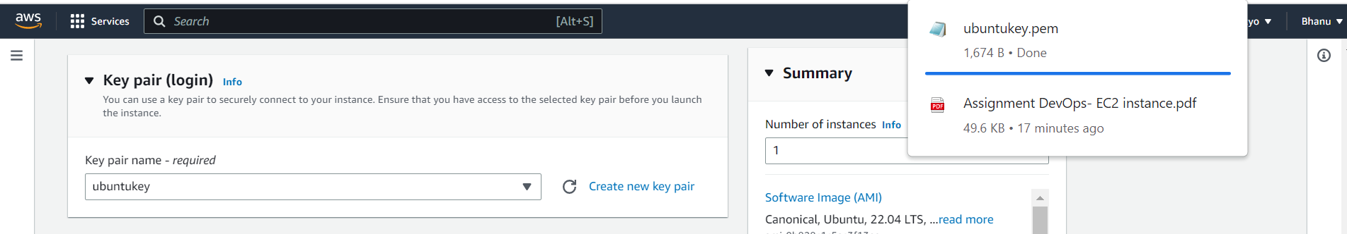

**Select the default VPC

**Step3**: Creating Security Group with SSH and HTTP/HTTPs Ports Enabled

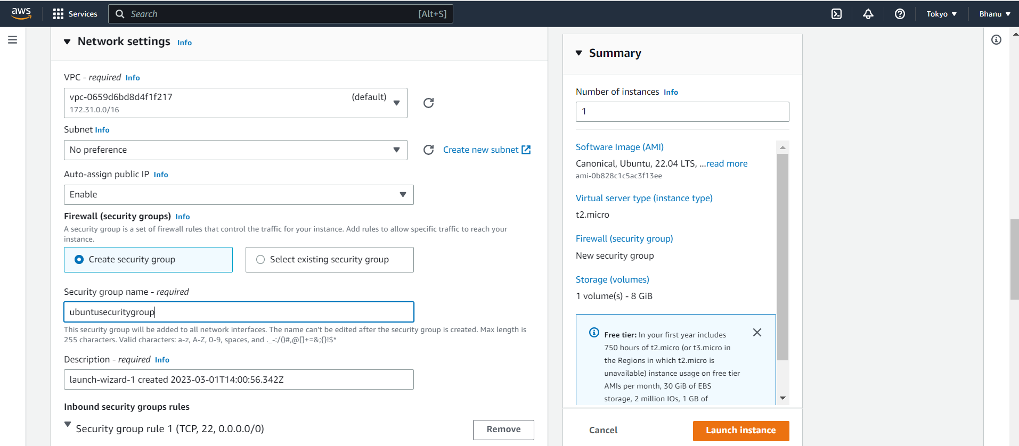

**Enable SSH port,HTTPS port and HTTP port.

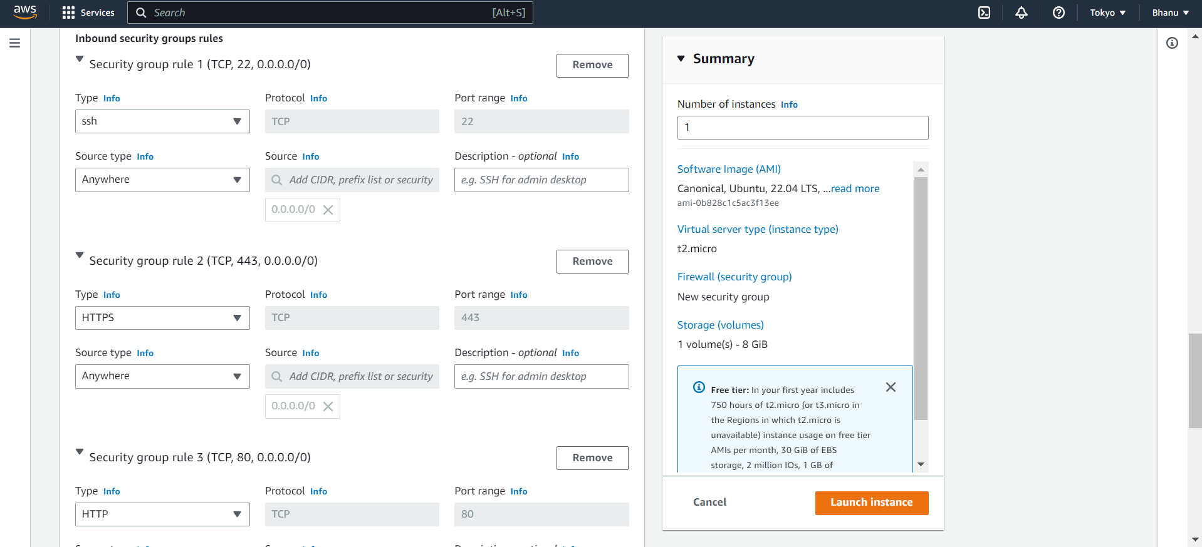

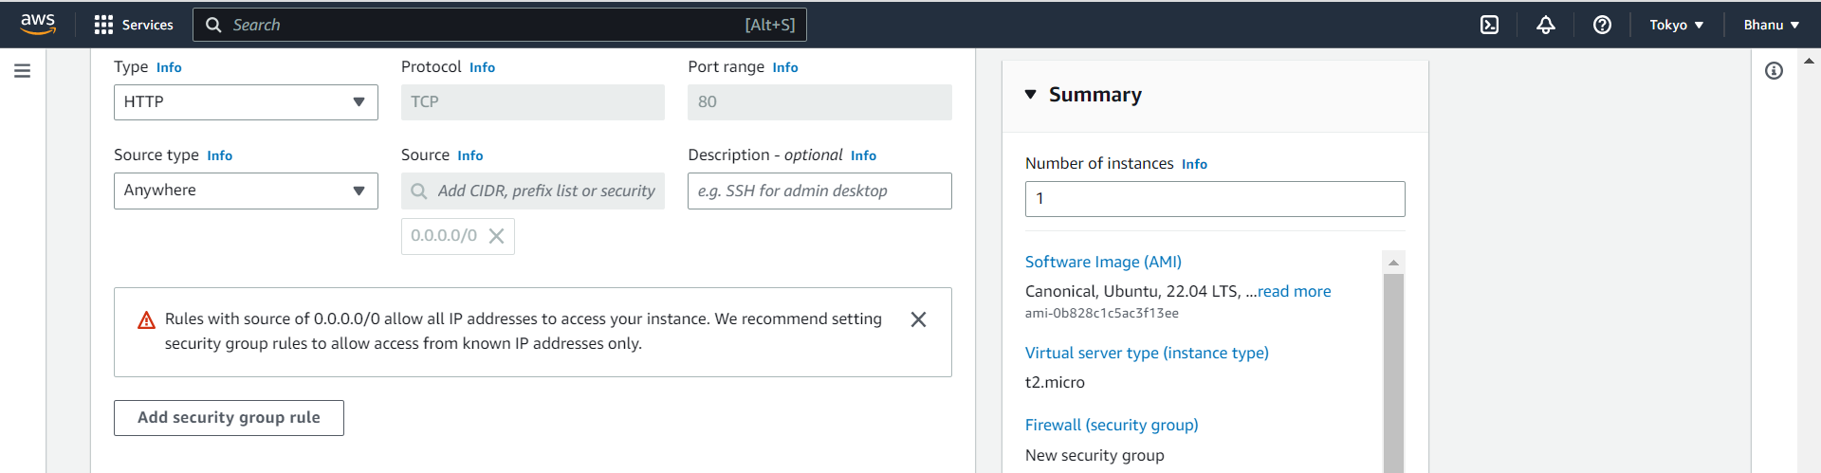

**Keep the storage settings default.

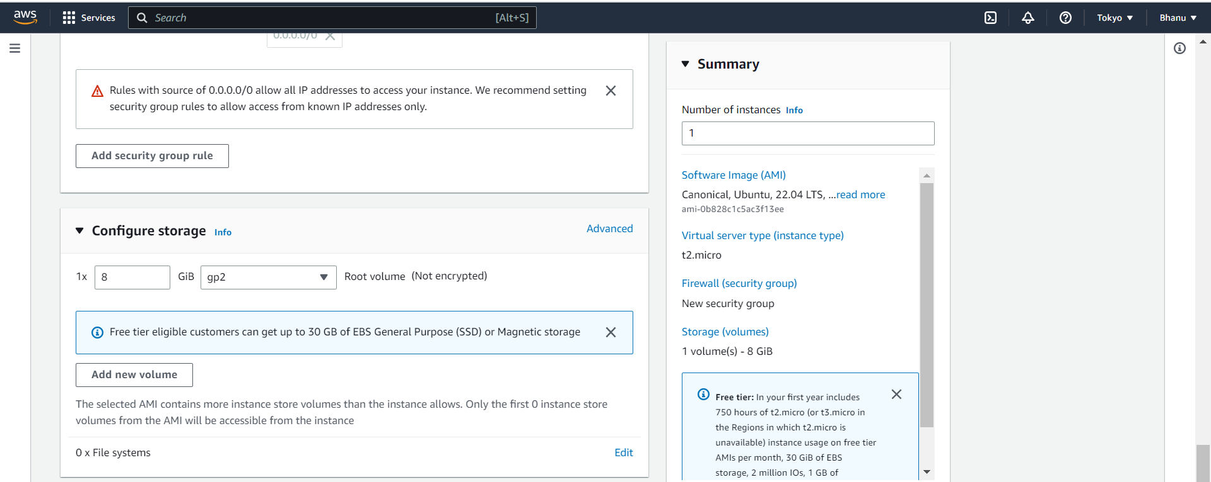

**Click on the Launch instance.

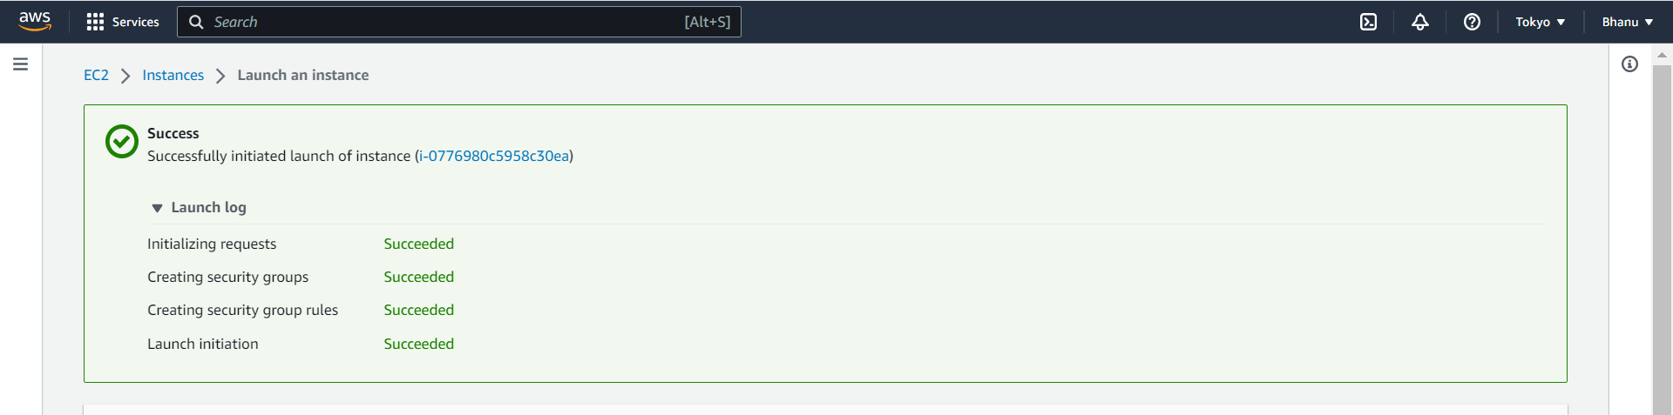

**The instance is now running.

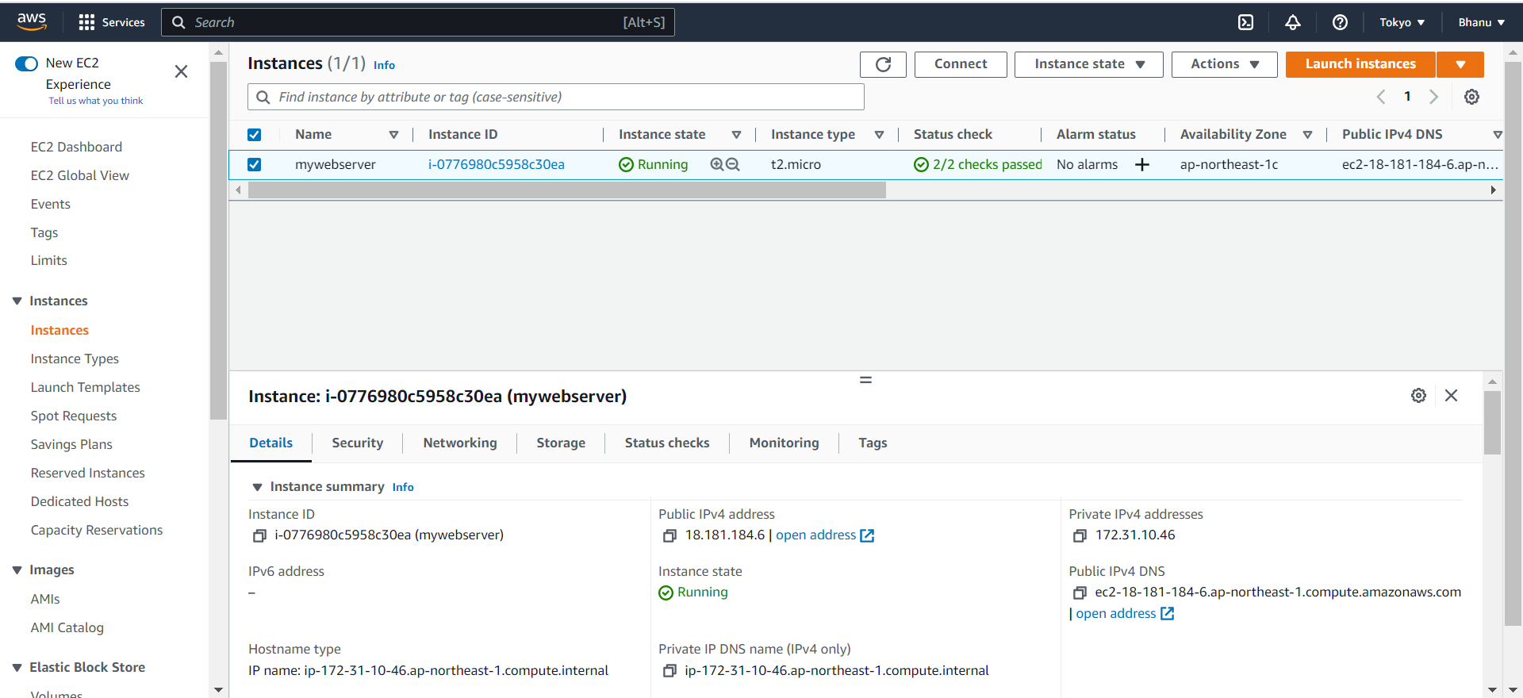

**Step 4**:

SSH Created EC2 Instance to local Machine.

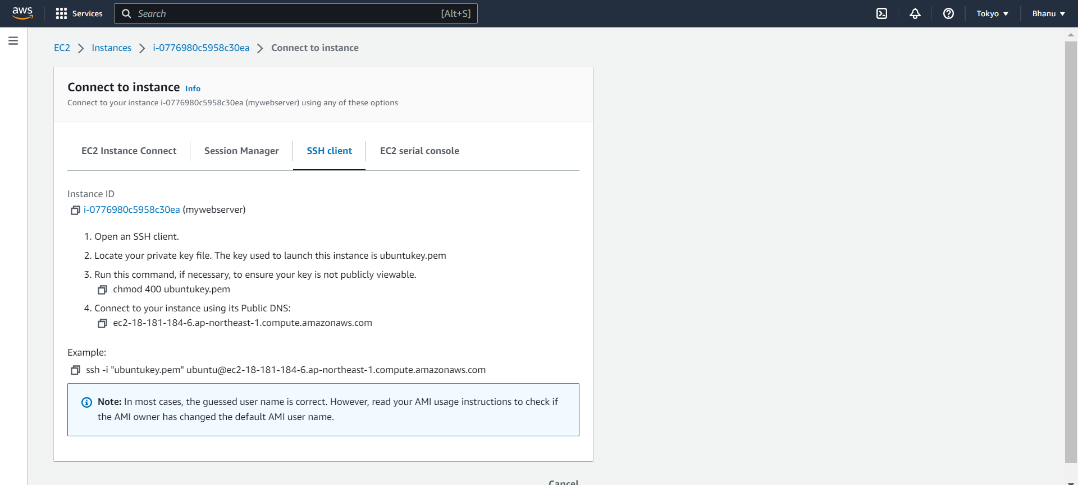

**Connect to the EC2 instance using the key pair through ssh.

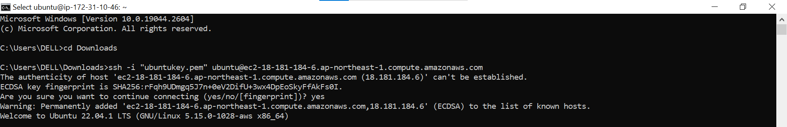

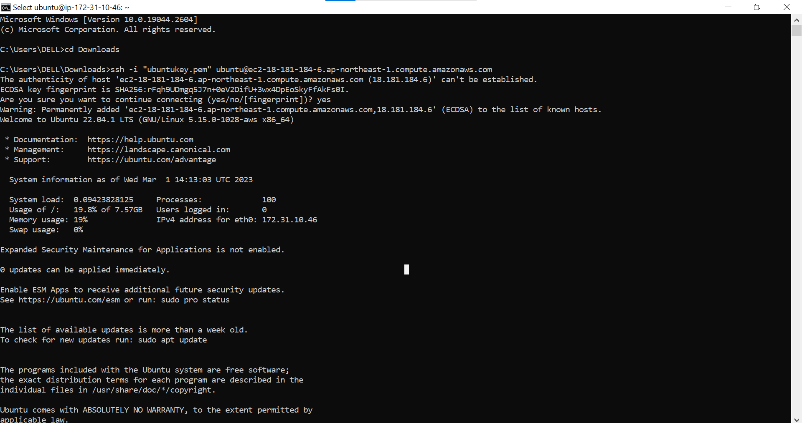

**Now we are connected to the EC2 instance.

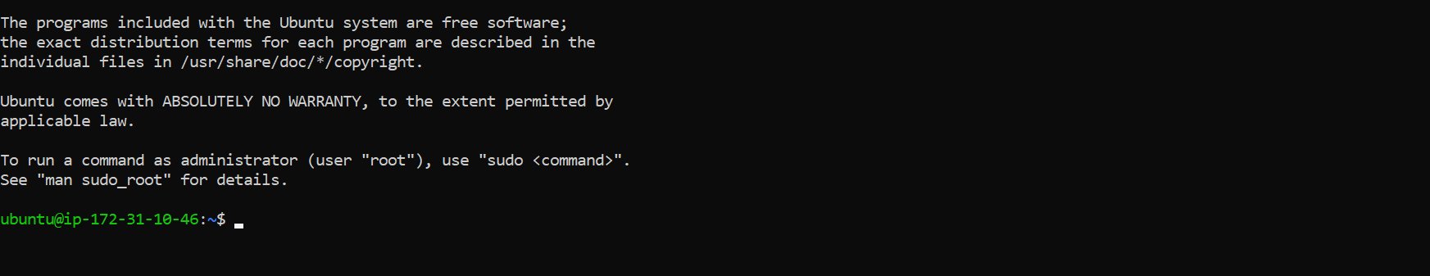

**To install the updates,the command is

**sudo apt update**

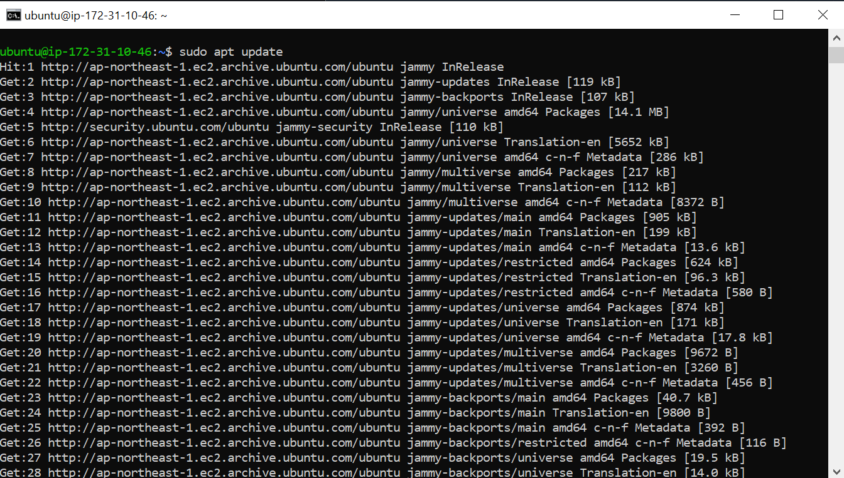

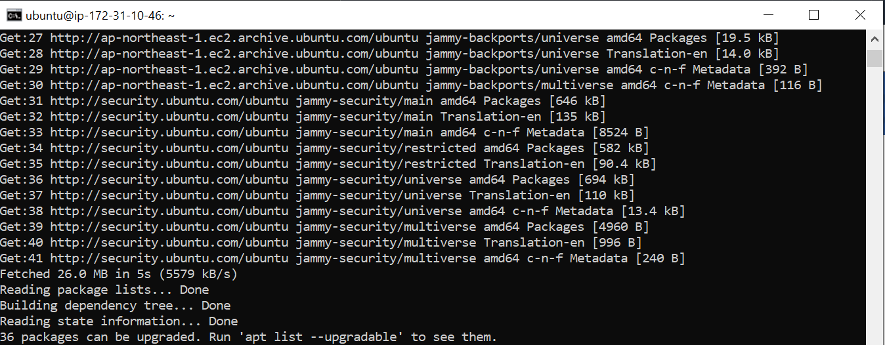

**Step 5:**

To install the node js give the below command.

**sudo apt install nodejs**

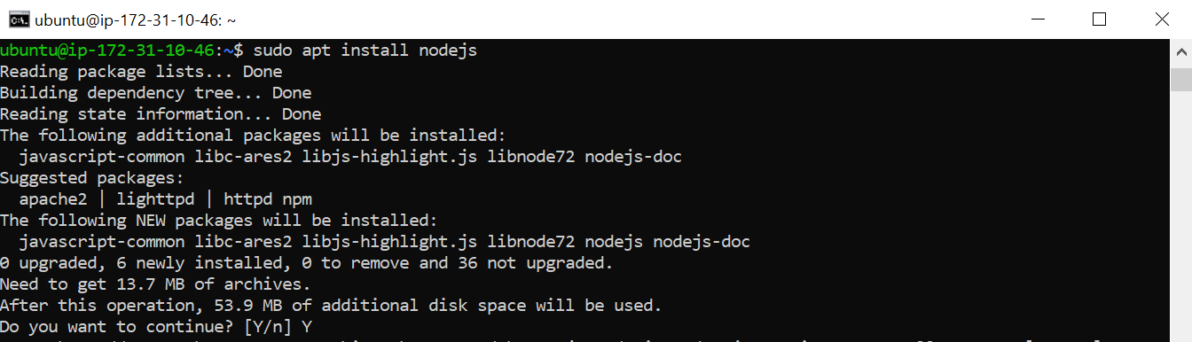

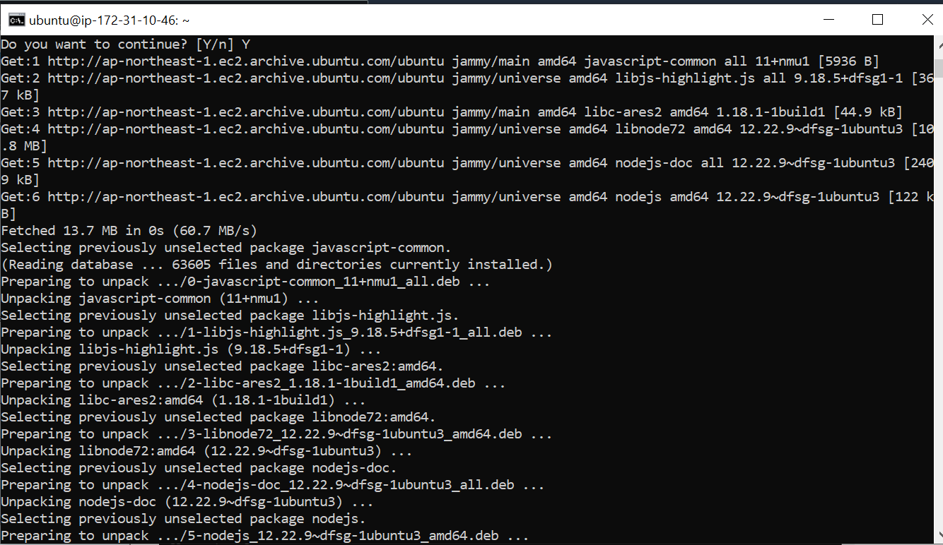

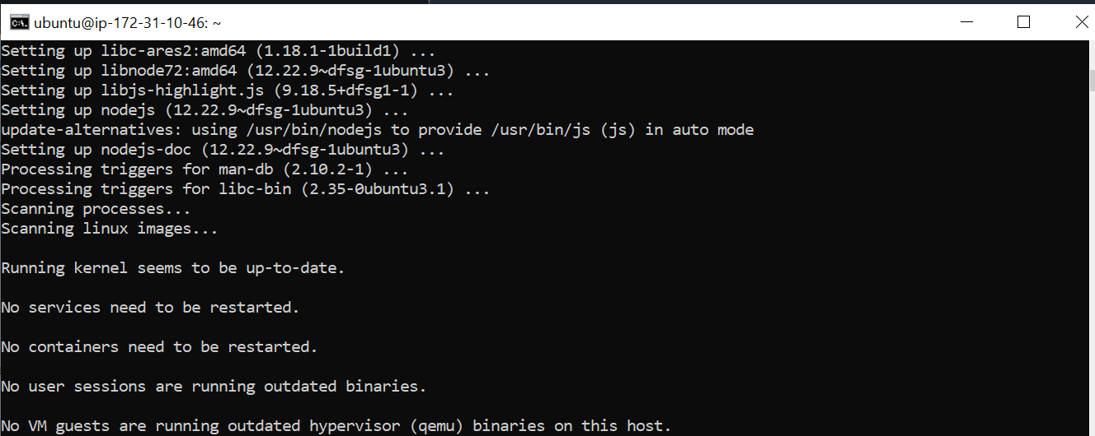

**Step 6:**

To check the status of nodejs ,whether it is installed or not,give the command

**node -v**



This command gives the output as v12.22.9 ,that indicates node js is successfully installed and it is the version of it.